**Clone the Existing repository:**

**To Clone copy the command line:**

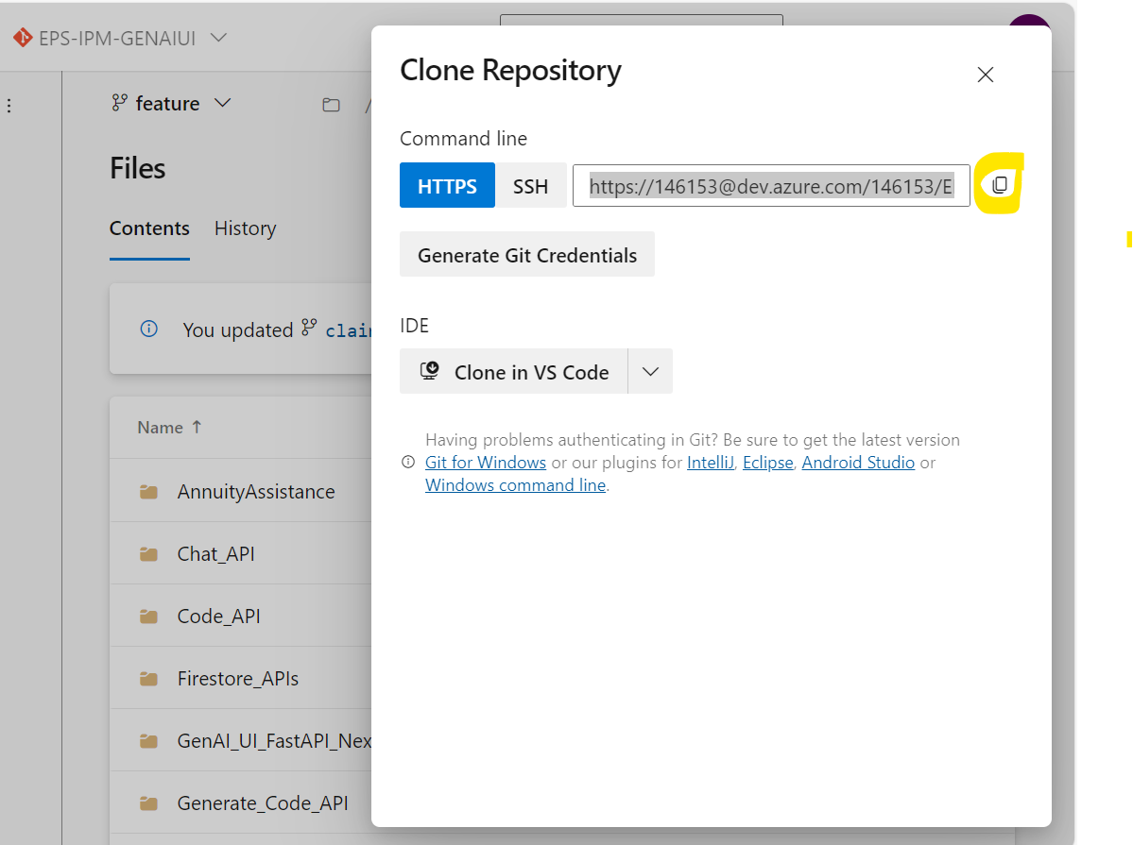

Open Git GUI and paste (copied from repository) in source location:

In Target Directory give the folder from your local file system:

Click on Clone button:

Now you will see current Branch as master:

Create a new branch in your local:

Add Name and select Tracking Branch, it will display all branches.  
Select feature branch and click on Create

Fetches feature branch

Current will change now to feature

Click on Branch->checkout

Select local branch which you have created and click checkout

You will see code at the file folder which you have given.

**Docker Login:**

Login to Docker Desktop

**Cloud login**

Open Google Cloud SDK Shell and enter the command -> **gcloud init**

for initial setup we have to give option **1)**Re-initialize this configuration with new settings

Network checks will happen if any proxy setup required question is asked (Y/n) please select with **N** and proceed (when working on office LAN)

For initial setup if your account was not displayed go for option 2 Popup will be opened in default browser and you will be signed into your account.

Once you are logged into your account the available project will be displayed please pick the relevant project option to finish Google cloud configuration setup

Once configuration setup is completed.

Enter the command -> gcloud auth application-default login

You will requested to sign again (pop up will opened in default browser)

Which will get all the necessary authentication details to your local system to be used when you are accessing google cloud resources.

**Post cloud login**

Open Vscode with Api which you want to deploy and run build commands in terminal.

docker buildx build --platform linux/amd64 -t ipm_vextexai_code_api_dev .

gcloud auth configure-docker us-central1-docker.pkg.dev

docker tag ipm_vextexai_code_api_dev us-central1-docker.pkg.dev/gbg-workspace/genaireposdev/ipm_vextexai_code_api_dev

docker push us-central1-docker.pkg.dev/gbg-workspace/genaireposdev/ipm_vextexai_code_api_dev:latest

Open Artifact repository in Cloud Console, you will see the image that is built.

https://console.cloud.google.com

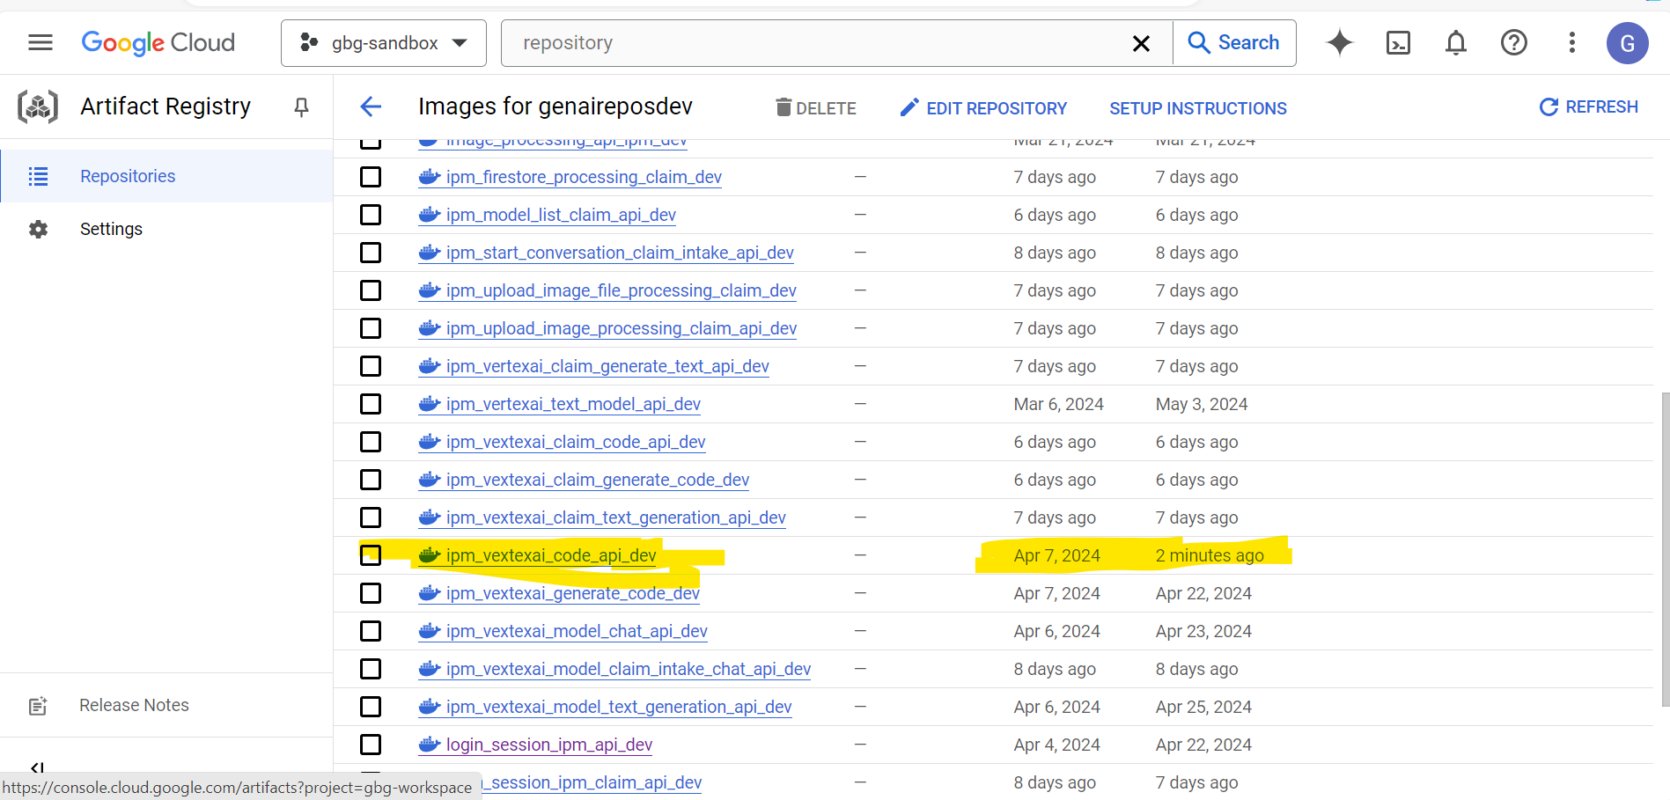

Go to Cloud run, to check the services.

Click on the service that you are deploying and click on EDIT &DEPLOY NEW REVISION

Click on select at Edit Container

You will see all the repositories, Select genaireposdev

After expanding genaireposdev you will see all the API’s deployed in that respository

**Select the image that is built**

Check for minimum number of instances and click on deploy.

Once it is deployed you will see the deployed revision.

**List Models:**

docker buildx build --platform linux/amd64 -t model_list_ipm_api_dev .

gcloud auth configure-docker us-central1-docker.pkg.dev

docker tag model_list_ipm_api_dev us-central1-docker.pkg.dev/gbg-workspace/genaireposdev/model_list_ipm_api_dev

docker push us-central1-docker.pkg.dev/gbg-workspace/genaireposdev/model_list_ipm_api_dev:latest

**Login Session:**

docker buildx build --platform linux/amd64 -t login_session_ipm_api_dev .

gcloud auth configure-docker us-central1-docker.pkg.dev

docker tag login_session_ipm_api_dev us-central1-docker.pkg.dev/gbg-workspace/genaireposdev/login_session_ipm_api_dev

docker push us-central1-docker.pkg.dev/gbg-workspace/genaireposdev/login_session_ipm_api_dev:latest

**Text Generation:**

docker buildx build --platform linux/amd64 -t ipm_vextexai_model_text_generation_api_dev .

gcloud auth configure-docker us-central1-docker.pkg.dev

docker tag ipm_vextexai_model_text_generation_api_dev us-central1-docker.pkg.dev/gbg-workspace/genaireposdev/ipm_vextexai_model_text_generation_api_dev

docker push us-central1-docker.pkg.dev/gbg-workspace/genaireposdev/ipm_vextexai_model_text_generation_api_dev:latest

**Generate Text:**

docker buildx build --platform linux/amd64 -t ipm_vertexai_text_model_api_dev .

gcloud auth configure-docker us-central1-docker.pkg.dev

docker tag ipm_vertexai_text_model_api_dev us-central1-docker.pkg.dev/gbg-workspace/genaireposdev/ipm_vertexai_text_model_api_dev

docker push us-central1-docker.pkg.dev/gbg-workspace/genaireposdev/ipm_vertexai_text_model_api_dev:latest

**Firestore API:**

docker buildx build --platform linux/amd64 -t firestore_processing_ipm_dev .

gcloud auth configure-docker us-central1-docker.pkg.dev

docker tag firestore_processing_ipm_dev us-central1-docker.pkg.dev/gbg-workspace/genaireposdev/firestore_processing_ipm_dev

docker push us-central1-docker.pkg.dev/gbg-workspace/genaireposdev/firestore_processing_ipm_dev:latest

**Chat API:**

docker buildx build --platform linux/amd64 -t ipm_vextexai_model_chat_api_dev .

gcloud auth configure-docker us-central1-docker.pkg.dev

docker tag ipm_vextexai_model_chat_api_dev us-central1-docker.pkg.dev/gbg-workspace/genaireposdev/ipm_vextexai_model_chat_api_dev

docker push us-central1-docker.pkg.dev/gbg-workspace/genaireposdev/ipm_vextexai_model_chat_api_dev:latest

**Start Conversation:**

docker buildx build --platform linux/amd64 -t vextexai_model_api_chat_ipm_dev .

gcloud auth configure-docker us-central1-docker.pkg.dev

docker tag vextexai_model_api_chat_ipm_dev us-central1-docker.pkg.dev/gbg-workspace/genaireposdev/vextexai_model_api_chat_ipm_dev

docker push us-central1-docker.pkg.dev/gbg-workspace/genaireposdev/vextexai_model_api_chat_ipm_dev:latest

**Upload_Image_Base64_Processing**

docker buildx build --platform linux/amd64 -t upload_image_file_ipm_dev .

gcloud auth configure-docker us-central1-docker.pkg.dev

docker tag upload_image_file_ipm_dev us-central1-docker.pkg.dev/gbg-workspace/genaireposdev/upload_image_file_ipm_dev

docker push us-central1-docker.pkg.dev/gbg-workspace/genaireposdev/upload_image_file_ipm_dev:latest

**Image_File_Processing_API**

docker buildx build --platform linux/amd64 -t upload-image-processing-api-ipm-dev .

gcloud auth configure-docker us-central1-docker.pkg.dev

docker tag upload-image-processing-api-ipm-dev us-central1-docker.pkg.dev/gbg-workspace/genaireposdev/upload-image-processing-api-ipm-dev

docker push us-central1-docker.pkg.dev/gbg-workspace/genaireposdev/upload-image-processing-api-ipm-dev:latest

**Code API:**

docker buildx build --platform linux/amd64 -t ipm_vextexai_code_api_dev .

gcloud auth configure-docker us-central1-docker.pkg.dev

docker tag ipm_vextexai_code_api_dev us-central1-docker.pkg.dev/gbg-workspace/genaireposdev/ipm_vextexai_code_api_dev

docker push us-central1-docker.pkg.dev/gbg-workspace/genaireposdev/ipm_vextexai_code_api_dev:latest

**Generate Code:**

docker buildx build --platform linux/amd64 -t ipm_vextexai_generate_code_dev .

gcloud auth configure-docker us-central1-docker.pkg.dev

docker tag ipm_vextexai_generate_code_dev us-central1-docker.pkg.dev/gbg-workspace/genaireposdev/ipm_vextexai_generate_code_dev

docker push us-central1-docker.pkg.dev/gbg-workspace/genaireposdev/ipm_vextexai_generate_code_dev:latest

**UI Commands:**

docker buildx build --platform linux/amd64 -t genainextjsuiipm_dev .

docker tag genainextjsuiipm_dev us-central1-docker.pkg.dev/gbg-workspace/genaireposdev/genainextjsuiipm_dev

docker push us-central1-docker.pkg.dev/gbg-workspace/genaireposdev/genainextjsuiipm_dev:latest